**Jersey City Bike Program During 2020/2021 Pandemic**

In this analysis we explore the usage of bicycles pertaining to the CityByke program during the pandemic events in Jersey. We focus in the Jersey City area only for the time frame January 2020 – April 2021.

The following map in the dashboard shows the most popular stations at any given time in the analyzed period.

One of the things to notice is that the bulk of rentals happen in central Jersey City, specifically most rentals and returns occur at Grove St Path station with just a few of them returning bicycles in Manhattan. A possible explanation is tourist staying in Jersey and commuting to Manhattan. The next visualization shows most popular stations across the considered timeframe.

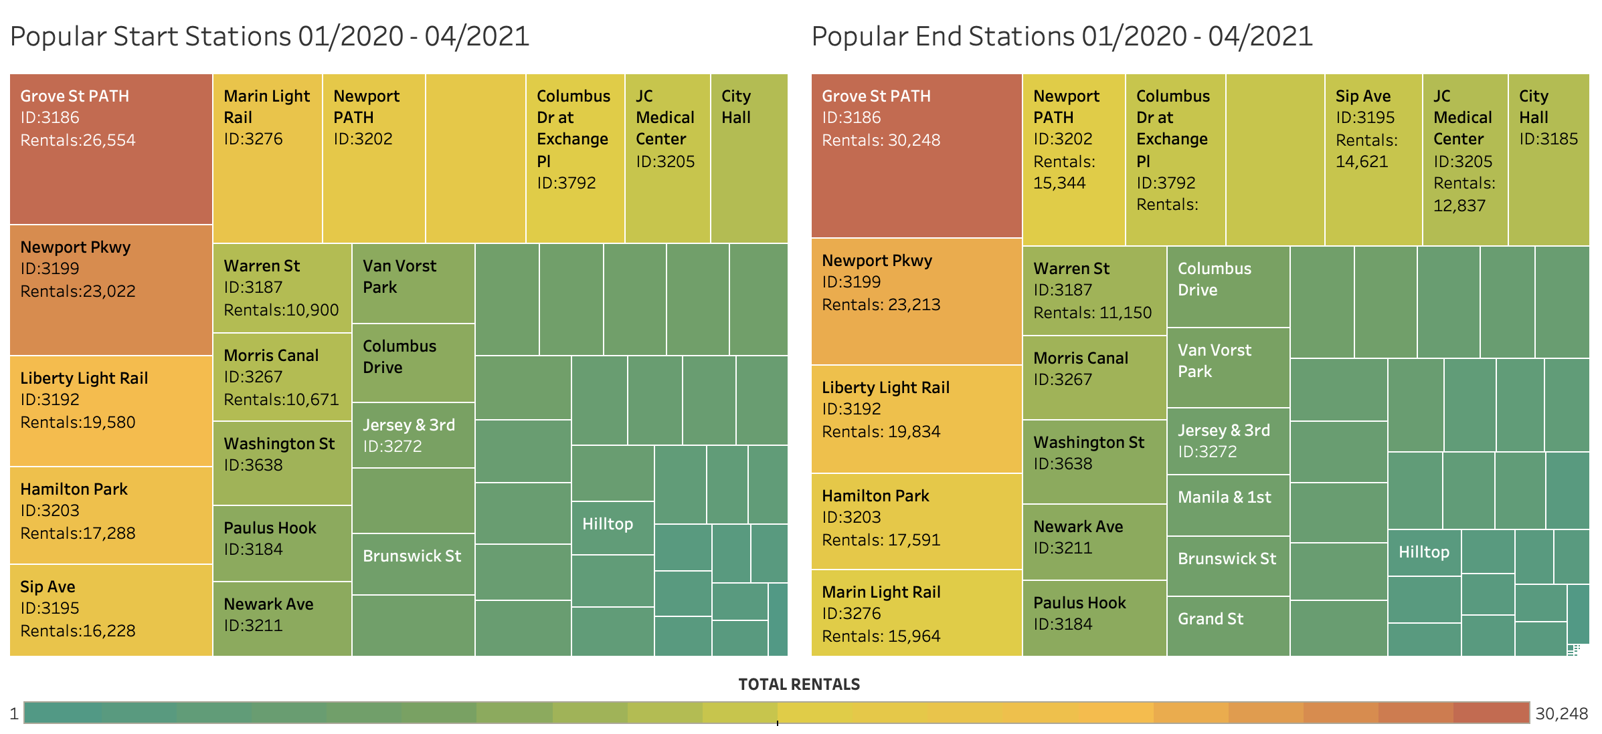

For the most popular station we can observe which stations are the most popular return points. One of the most popular returning points is the Hamilton Park station. This information could potentially be used to plan restocking of Grove St PATH station over periods of time with high activity.

In the previous visualization we can also observe that high activity times happen from 16:00 to 20:00 which are peak hours for commuting after work. We can take a closer look at usages times in the following visualization per month and hour.

One of the things to notice is that usage decreases during winter months which is expected. Now, during spring it is expected to start ramping up, as shown in the data from 2021; however, when we take a look at this at the February-March 202 timeframe, we see a significant decrease. This corresponds with the lockdown in the Jersey City/Manhattan area at the beginning of the COVID-19 pandemic.

Finally, at least in the Jersey City area, there is a higher number of female users in the program which might be due to safer bicycle driving conditions in comparison to Manhattan. Additionally, towards the beginning of 2021, the number of undefined users increased. These two phenomena will have to be confirmed by analysis data from Manhattan over a longer period of time.